Western Union Enrollment for Select IEEE Concur Users

Introduction
As you are aware, IEEE launched a new, more efficient expense reporting tool called Concur. The payment service integrated with Concur has the ability to send expense report payments to many countries throughout the world, however, not all countries are supported. For those countries that are not supported by the Concur payment network, IEEE has leveraged the services of Western Union to act as a payment vehicle in lieu of Concur.

To register with Western Union please follow these easy steps:

- Click the following link to begin your registration. This link will also be posted on the Concur home page. https://payee.globalpay.westernunion.com/PayeeManager/BeneficiaryEnrollment/SpecifyPayeeID.aspx?id=F1810E0E0077373DA43DBACFF6679AAB

- Enter your eight digit IEEE member number in the Payee ID field. You may leave this field blank if you do not know your IEEE member number. Click “Next”.
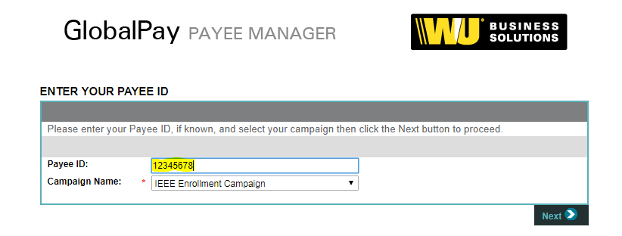

- Complete the required fields then click “Next”. Fields with a red asterisk are required.
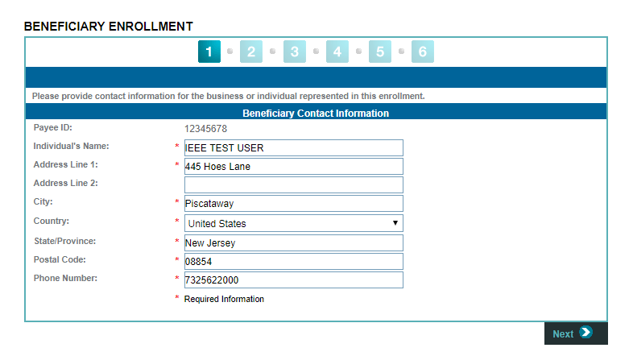

- Continue to populate the required fields then click “Next”.
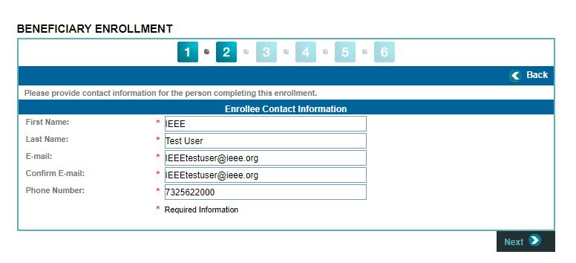
- Create a Western Union username and password.
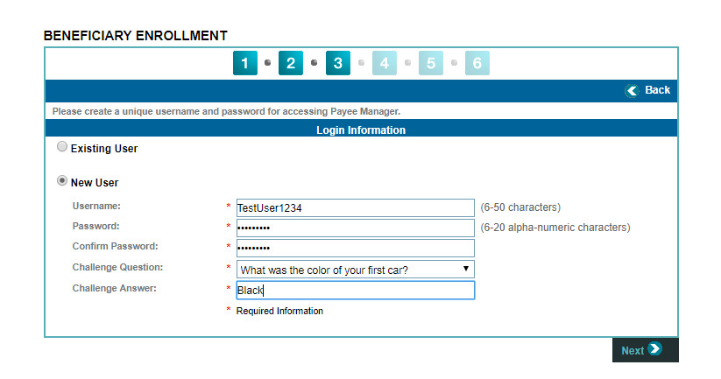
- Enter your banking information then click “Next”. Take advantage of the “Find A Bank” button if you need assistance identifying your bank. You also have the option to select the currency you wish to be reimbursed in.
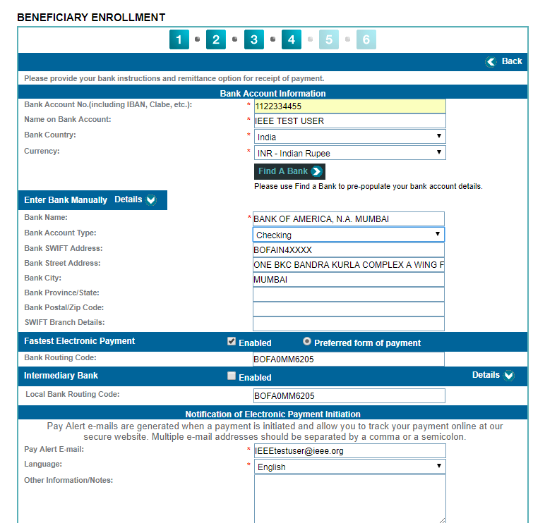

- Agree to the Western Union terms by clicking the checkbox near the bottom left of the screen. Select “Submit Enrollment Request”.
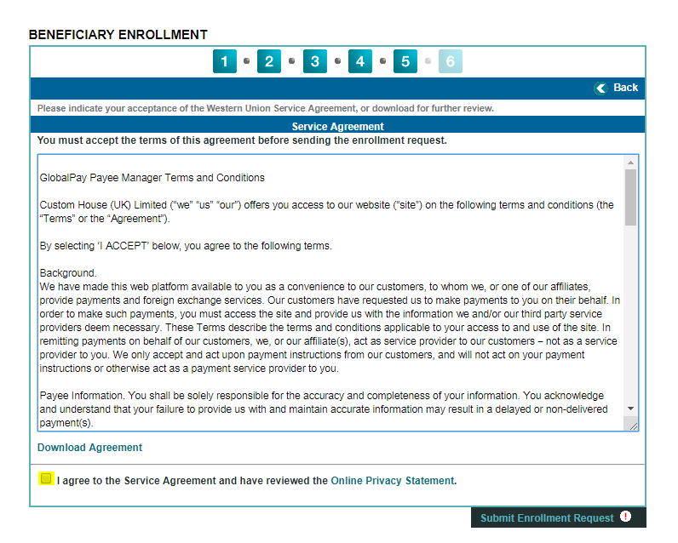
- Review the confirmation screen and verify all data is accurate. Click “Confirm”.

As a recipient of this notification, you are required to complete this one-time enrollment with Western Union before you can begin receiving electronic reimbursements from IEEE. Please note you are responsible for maintaining your banking information with Western Union and making any updates when needed.

If any assistance is required, you may contact Western Union using the following methods:
- By email: epayvendormanagement@westernunion.com
- By phone: 1-800-815-2460 option 1

